**View the Live Website Here:**  
[**https://v0-medication-app-refactor.vercel.app/**](https://v0-medication-app-refactor.vercel.app/)

## **Market Scan Summary**

Below is a **brief overview** of two popular medication management apps **Medisafe** and **MyTherapy** focusing on **user characteristics**, **user tasks**, and **critical tasks**. This analysis reflects insights derived from **AI-assisted research**, including published user statistics and app feature documentation.

### **1. Medisafe**

#### **User Characteristics**

* **Broad Demographics**: Younger adults (under 45) comprise over half of users, yet many seniors also use Medisafe to manage chronic conditions (e.g., diabetes, hypertension, HIV).
* **High Medication Complexity**: Nearly 20% of U.S. users take eight or more medications, indicating frequent use by individuals with complex regimens.
* **Varied Motivations**: Users seek to avoid missed doses or double-dosing and appreciate easy, intuitive features for daily medication management. Caregivers also utilize Medisafe (via Medfriend) to monitor loved ones’ adherence.

#### **User Tasks**

1. **Medication Setup**
   1. Adding drugs, dosages, schedules, including daily or PRN (“as needed”) meds.
2. **Reminders & Alerts**
   1. Automatic push notifications for each dose. If unacknowledged, a follow-up alert is sent.
3. **Dose Tracking (Taken/Skipped)**
   1. Logging each dose to update adherence percentages and prevent double-dosing.
4. **Profile Management & Sharing**
   1. Multiple profiles (e.g., for family members), plus caregiver alerts (Medfriend).
5. **Refill & Renewal Reminders**
   1. Alerts when medication supply is running low.
6. **Health Measurement Tracking**
   1. Logging blood pressure, glucose, or other metrics, often synced with Apple Health.
7. **Drug Interaction Checks**
   1. Automated warnings about potentially harmful drug combinations.
8. **Educational Resources**
   1. Condition-specific articles, videos, and tips offered within the app.

#### **Critical Tasks (Safety-Sensitive)**

* **Timely Adherence**: Responding to reminders and taking meds on schedule.
* **Accurate Dose Logging**: Ensuring each taken dose is promptly marked to prevent confusion or double-dosing.
* **Updating Medication Changes**: Editing dosage/frequency in the app when prescriptions change.
* **Refill & Interaction Alerts**: Heeding refill prompts and cautionary flags for drug interactions.

Medisafe’s core strength lies in **user-friendly daily reminders** and **robust logging**, helping both individual patients and caregivers maintain consistent adherence.

### **2. MyTherapy**

#### **User Characteristics**

* **Global Audience**: Over 4 million users, ranging from younger adults to seniors (including many 60+).
* **Chronic Conditions**: Popular for those managing illnesses like ADHD, asthma, diabetes, heart disease, and HIV.
* **Motivations**: Maintain consistent dosing, track health metrics, and share progress with family or doctors.

#### **User Tasks**

1. **Setting Up Medication Reminders**
   1. Creating a personalized medication schedule from a built-in drug database.
2. **Receiving & Responding to Alerts**
   1. Marking each dose as taken, skipped, or snoozed. Persistent notifications reduce missed doses.
3. **Logging Intake & Adherence Tracking**
   1. Detailed records of when and why doses were missed or taken.
4. **Tracking Health Data**
   1. Monitoring vitals (blood pressure, glucose, mood, symptoms) within the same interface.
5. **Managing Medication Supply (Refill Reminders)**
   1. Proactive alerts to restock essential medications.
6. **Reviewing Progress & Sharing Reports**
   1. Generating monthly summaries or sharing adherence logs with healthcare providers.

#### **Critical Tasks (Safety-Critical)**

* **Attending to Scheduled Alerts**: Missing notifications can result in skipped doses and worsened conditions.
* **Accurate Logging**: Marking doses correctly to prevent overdose or underdose.
* **Keeping Medication Lists Current**: Outdated schedules cause incorrect reminders, risking serious harm.
* **Refills & Continuity of Therapy**: Running out of medication can cause acute health crises.

MyTherapy’s emphasis on **holistic health tracking** (vitals, symptoms) alongside **medication reminders** helps users see the broader impact of adherence on overall well-being.

### **3. Insights from AI-Assisted Research**

Both **Medisafe** and **MyTherapy** offer robust reminder features, logging functions, and refill alerts—each app addresses **critical safety tasks** like preventing missed doses and double-dosing. User reviews highlight **intuitive interfaces** and **helpful notifications** as key adoption drivers. Caregiver integration (Medfriend for Medisafe, Team feature for MyTherapy) appeals to families managing multiple patient profiles.

In summarizing the market:

* **Medisafe** excels at **interaction checks** and **comprehensive scheduling** (including PRN meds).
* **MyTherapy** stands out for **holistic health data tracking** and **family engagement**.
* Both prioritize **adherence** as the most critical factor for better health outcomes.

By leveraging **AI-based** data collection and analysis, these insights confirm that **timely reminders**, **dose tracking**, and **user-friendly experiences** are crucial for sustained patient engagement and medication safety.

**Observation Report Summary**

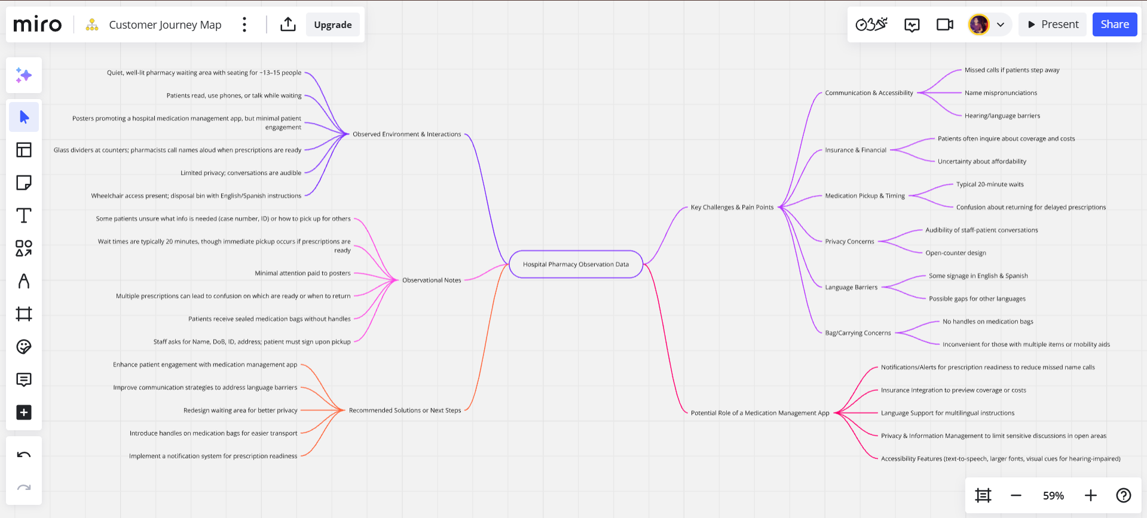

**1. Introduction and Methodology**

I visited the Beth Israel Deaconess Medical Center located at 330 Brookline Ave, Boston, MA 02215. Over the course of one hour, I conducted an unobtrusive observation at the hospital pharmacy area to better understand patient behaviors, interactions, and the environmental context. Approximately 40–50 individuals were observed during this time. Notes were taken discreetly using Google Keep, ensuring minimal interference with patient or staff activities. The primary goal was to capture real-time behaviors, potential pain points, and overall user experiences in relation to medication dispensing, waiting processes, and information exchange.

**2. Observed Environment and Patient Interactions**

The pharmacy setting was reasonably quiet (apart from conversations) and well-lit. Seating options (including seven chairs and a central sofa) comfortably accommodated around 13–15 people, though the number of individuals present in the waiting area varied from 1 to 8 at any given moment. Patients typically engaged in a variety of waiting-time activities, such as reading, browsing on their phones, or conversing with companions. Multiple posters were displayed encouraging download of the hospital’s medication management application, yet it did not appear that any patients actively focused on these posters.

The physical layout included protective glass dividers at each counter station. Pharmacists called patients by name when prescriptions were ready; however, challenges could arise for those with hearing impairments or language barriers. Patient privacy was limited conversations between staff and patients remained audible throughout the pharmacy. Accessibility was partially addressed with wheelchair access in the lobby area, though detailed measures for individuals with disabilities (e.g., visual or hearing impairments) were not readily visible. Signage regarding a medication disposal bin was prominently provided in English and Spanish, reflecting an effort to cater to a multilingual patient population.

**3. Key Challenges, Pain Points, and Sources of Confusion**

1. **Communication and Accessibility**: Some patients were not in the immediate waiting area when their names were called, which could lead to confusion or missed pickups. Name pronunciations or hearing difficulties could exacerbate this issue.
2. **Insurance and Financial Considerations**: Patients frequently inquired about insurance coverage and medication costs, sometimes expressing uncertainty about whether they could afford prescriptions.
3. **Medication Pickup and Timing**: Wait times of approximately 20 minutes were common, yet some prescriptions were delayed or only available at later dates. Patients appeared unsure about whether to return the same day or on subsequent days.
4. **Privacy**: Conversations were audible due to the open-counter design. Patients hesitant to disclose specific medication needs or personal details might experience discomfort.
5. **Language Barriers**: While English and Spanish materials were visible, there remained the possibility that non-English-speaking patients (or those with limited English/Spanish proficiency) could encounter communication challenges.
6. **Bag and Carrying Concerns**: Medication bags did not have handles, which may pose difficulties for those already carrying multiple personal items or relying on mobility aids.

Of the 40–50 people observed, at least a quarter seemed to struggle briefly with communication or procedural uncertainties, primarily around insurance inquiries or instructions on when to retrieve medication. A smaller number (fewer than five) appeared unsure about the steps to pick up medication on behalf of someone else.

**4. Reflection on Potential Use of the Medication Management Application**

In light of the observed challenges, a well-designed medication management application could address several pain points:

* **Notifications and Reminders**: Push notifications or text alerts could inform patients of prescription readiness, mitigating the issue of missed name calls and reducing confusion for those stepping away.
* **Insurance Integration**: An in-app feature allowing patients to check coverage or estimated costs before arriving may ease financial uncertainty and reduce the number of in-person inquiries.
* **Language Support**: Bilingual or multilingual support within the app, including step-by-step instructions on pick-up procedures, could bridge language gaps and enhance clarity.
* **Privacy and Information Management**: A secure digital platform could let patients review sensitive information (e.g., medication instructions, possible side effects, dose changes) without needing to discuss details publicly.
* **Accessibility Features**: Customizable fonts, text-to-speech for individuals with visual or reading limitations, and clear visual notifications for users with hearing impairments could greatly improve inclusivity.

Overall, these observations suggest that an application focusing on clear communication, timely updates, and support for diverse patient needs would be highly valuable in a busy hospital pharmacy context,

Below is an **Analysis** of the observed findings, organized by **task** and categorized to highlight user needs, pain points, and environmental factors. Each user need is stated in the format *“The user needs … in order to …”*, reflecting a clear relationship between a requirement (what is needed) and its purpose (why it matters).

## **1. Prescription Pick-Up (New and Existing Medications)**

### **Observations & Pain Points**

* Patients often wait in line and must be present when their name is called; if they step away (for tests or errands), they risk missing their turn.
* Some medications are immediately ready, while others may only be available later. Patients appear uncertain about returning the same day or coming back on a future date.

### **Environmental Factors & Surprises**

* **Name-calling practice** is prone to miscommunication (accents, pronunciation, hearing impairments).
* **Wait times** can vary (commonly ~20 minutes), but queues change quickly if multiple prescriptions are not all ready at once.

### **User Needs**

* **The user needs** timely, clear notifications **in order to** know exactly when medications are ready.
* **The user needs** a straightforward way to verify if a partial prescription is ready **in order to** avoid multiple trips or missed pickups.

## **2. Insurance and Cost Clarifications**

### **Observations & Pain Points**

* Patients regularly inquire about insurance coverage (whether a prescription is fully/partially covered).
* Some patients appear uncertain about copays or total costs; delays arise when they must verify coverage.
* If a medication is too expensive, patients may seek alternatives or skip prescriptions.

### **Environmental Factors & Surprises**

* **Financial constraints** can lead to confusion and extended wait times for cost clarifications.
* **In-person inquiries** (which can be lengthy) add to line congestion.

### **User Needs**

* **The user needs** a way to check insurance coverage or estimated costs digitally **in order to** minimize in-person confusion and speed up the pickup process.
* **The user needs** an option to compare medication prices or alternatives **in order to** make informed decisions that fit their budget.

## **3. Privacy and Communication**

### **Observations & Pain Points**

* Pharmacist counters are partitioned by glass, but conversations can still be overheard.
* Some patients may hesitate to discuss sensitive information (e.g., medication for stigmatized conditions).
* Name-calling and open-audible dialogues risk breaching privacy for those uncomfortable revealing their condition or medications publicly.

### **Environmental Factors & Surprises**

* Despite the partitioning, the **sound carries**, offering little confidentiality.
* **Language barriers** (English/Spanish) and potential for hearing impairment intensify communication challenges.

### **User Needs**

* **The user needs** a private or lower-volume communication channel **in order to** protect personal health information.
* **The user needs** alternative notification methods (e.g., text, app alert, screen display) **in order to** accommodate hearing-impaired or multilingual patients.

## **4. Waiting and Idle Time Management**

### **Observations & Pain Points**

* Patients waiting 20 minutes (sometimes more) often read, chat on the phone, or watch videos, but some do not pay attention to posted materials.
* Missing the name call while waiting or being elsewhere (cafeteria, lobby, restroom) can cause delays.

### **Environmental Factors & Surprises**

* **Posters** (including those advertising a medication management app) go largely unread, suggesting limited engagement with static visuals.
* The waiting area is relatively comfortable (seating for ~13–15 people, well-lit) but not always conducive to receiving real-time notifications if patients leave the immediate vicinity.

### **User Needs**

* **The user needs** mobile or digital alerts **in order to** be promptly informed even if they step away from the waiting area.
* **The user needs** accessible, engaging information channels (e.g., short videos, dynamic displays) **in order to** notice important reminders or app instructions during idle time.

## **5. Verification and Data Retrieval**

### **Observations & Pain Points**

* Pharmacists ask for name, date of birth, ID, address, and patients sometimes must remember a “case number.”
* Some individuals picking up medications on behalf of others feel unsure about the required information (e.g., full name, date of birth, relationship, proof of consent).

### **Environmental Factors & Surprises**

* **Multiple prescriptions** can be partially ready; verifying correct items or dosage instructions can be confusing, especially if the patient is picking up for someone else.
* The presence of a **unique case number** or a longer ID number may require clarification (patients are unsure why they have more than one reference number).

### **User Needs**

* **The user needs** a simple, centralized way to confirm identity details **in order to** avoid confusion or errors when picking up for themselves or others.
* **The user needs** a digital record or checklist **in order to** confirm which prescriptions are ready and which still require processing.

## **6. Allergies, Side Effects, and Counseling**

### **Observations & Pain Points**

* Patients occasionally inquire about allergies, but in a busy setting, these conversations are brief and sometimes overheard.
* The facility does have a designated counseling area, but it may not always be used or noticed by patients.

### **Environmental Factors & Surprises**

* **Counseling environment** is available but not necessarily private; some patients may skip formal counseling if pressed for time or anxious about being overheard.

### **User Needs**

* **The user needs** a secure, clearly indicated private space **in order to** discuss allergy concerns or sensitive medication details.
* **The user needs** immediate digital access to medication info (e.g., warnings, side effects) **in order to** supplement brief or hurried pharmacist interactions.

## **7. Medication Disposal and Environmental Awareness**

### **Observations & Pain Points**

* A disposal bin is present with instructions in English and Spanish, but needles are not allowed.
* Not all patients appear aware of proper disposal guidelines if they use injectables or other specialty medications.

### **Environmental Factors & Surprises**

* The disposal bin usage guidelines are lengthy, and patients rarely stand to read multi-line posters.

### **User Needs**

* **The user needs** concise, clear directions on safe medication (and sharps) disposal **in order to** follow proper disposal procedures.
* **The user needs** alternate disposal options or directions for items not permitted in the current bin (e.g., needles) **in order to** avoid confusion and potential health hazards.

## **8. Accessibility and Mobility**

### **Observations & Pain Points**

* Some patients use wheelchairs or have mobility constraints, carrying multiple bags or personal items.
* The medication bag has no handle, adding difficulty for those with limited physical capacity or those already juggling items.

### **Environmental Factors & Surprises**

* **No-handle bags** can be inconvenient, especially in a hospital context where many patients already carry medical equipment or personal belongings.

### **User Needs**

* **The user needs** easy-to-carry medication packaging **in order to** transport prescriptions conveniently, especially if using mobility aids.
* **The user needs** accessible counters, signage, and support **in order to** facilitate pick-up for those with limited mobility or dexterity.

### **Overall Insights**

Many of these issues highlight **communication gaps**, **privacy concerns**, and **logistical challenges** in a high-traffic pharmacy environment. Patients’ ability to navigate these challenges often depends on **clear instructions**, **digital support**, and an environment that respects **mobility, language, and privacy needs**. Surprising elements, such as low engagement with static posters and the audible nature of private conversations, underscore the importance of **alternative solutions**—e.g., more discreet communication channels or digital alerts—to ensure a smoother, more inclusive pharmacy experience.

### **Observation Analysis & Prioritization Report**

The following sections outline key **pain points, environmental factors, and user needs** for each task.

### **Prescription Pick-Up (New & Existing Medications)**

**Impact of Missing or Misunderstanding Information:**

* **High risk** of **missed doses** or **treatment delays** if patients are unaware their prescription is ready.
* **Confusion about partially ready prescriptions** leads to unnecessary trips or delays in obtaining medications.

**User Needs:**

* *The user needs* **timely, clear notifications** *to know exactly when medications are ready*.
* *The user needs* **a way to verify partial prescription readiness** *to avoid unnecessary trips or delays*.

**Priority:** 🟥 **High** – Directly affects medication adherence.

### **Insurance & Cost Clarifications**

**Impact of Missing or Misunderstanding Information:**

* **High likelihood** that patients **will not fill** prescriptions if they do not understand costs or coverage.
* **Delays in verification** contribute to **longer pharmacy wait times** and patient frustration.

**User Needs:**

* *The user needs* **a way to check insurance coverage or estimated costs digitally** *to avoid delays and confusion*.
* *The user needs* **an option to compare medication prices or alternatives** *to make informed financial decisions*.

**Priority:** 🟥 **High** – Medication cost is a **decisive factor** in adherence.

### **Privacy & Communication**

**Impact of Missing or Misunderstanding Information:**

* **Patients may hesitate to disclose** sensitive information (e.g., HIV, mental health, reproductive medications).
* **Overheard conversations** increase **privacy concerns**, discouraging open discussions.
* **Language barriers & hearing impairments** cause **miscommunication**.

**User Needs:**

* *The user needs* **a private or lower-volume communication channel** *to protect personal health information*.
* *The user needs* **alternative notification methods (text, app alert, screen display)** *to accommodate hearing-impaired or multilingual patients*.

**Priority:** 🟧 **Medium** – Privacy affects **comfort and willingness to share information** but does not **immediately** prevent access to medication.

### **Waiting & Idle Time Management**

**Impact of Missing or Misunderstanding Information:**

* **Patients miss their name call**, delaying prescription pickup.
* **Engagement with posters is low**, meaning **medication management app promotions go unnoticed**.

**User Needs:**

* *The user needs* **mobile or digital alerts** *to be notified even if they step away*.
* *The user needs* **interactive or engaging information channels** *to be aware of pharmacy resources while waiting*.

**Priority:** 🟧 **Medium** – Affects efficiency but does **not** prevent medication pickup.

### **Verification & Data Retrieval**

**Impact of Missing or Misunderstanding Information:**

* **Confusion about case numbers and IDs** can lead to **delays**, but ultimately, **physical ID is required**, so the impact of digital solutions is **minimal**.
* **Patients picking up for others may not know what information is needed**, causing frustration.

**User Needs:**

* *The user needs* **a clear checklist of required verification details** *to streamline the process*.
* *The user needs* **a way to confirm which prescriptions are ready** *to prevent unnecessary confusion or waiting*.

**Priority:** 🟩 **Low** – **ID verification is a legal requirement**, so digital solutions offer **limited** benefit.

### **Allergies, Side Effects & Counseling**

**Impact of Missing or Misunderstanding Information:**

* **Skipping counseling** can lead to **serious health risks** (e.g., allergic reactions, incorrect medication use).
* **Patients may receive unclear or rushed explanations** and may forget instructions later.

**User Needs:**

* *The user needs* **a clearly indicated private counseling space** *to feel comfortable discussing sensitive concerns*.
* *The user needs* **digital access to medication info (warnings, side effects)** *to supplement brief in-person interactions*.

**Priority:** 🟥 **High** – **Medication misuse or allergic reactions pose serious health risks**.

### **Medication Disposal & Environmental Awareness**

**Impact of Missing or Misunderstanding Information:**

* **Improper disposal (flushing, trash disposal)** creates **environmental hazards**.
* **Lack of awareness about proper disposal for injectables** leads to **incorrect disposal of sharps/needles**.

**User Needs:**

* *The user needs* **concise, clear instructions on safe medication disposal** *to prevent environmental harm*.
* *The user needs* **alternate disposal options for restricted items (e.g., needles)** *to avoid confusion and improper disposal*.

**Priority:** 🟧 **Medium** – Important for **environmental safety**, but **not as urgent** as medication adherence.

### **Accessibility & Mobility**

**Impact of Missing or Misunderstanding Information:**

* **Patients with mobility constraints struggle** with carrying prescriptions, reaching counters, or handling small medication bags.
* **Poor signage or counter height may create access issues** for wheelchair users.

**User Needs:**

* *The user needs* **medication packaging that is easy to carry** *to improve accessibility*.
* *The user needs* **accessible pharmacy counters and pickup support** *to ensure ease of medication retrieval*.

**Priority:** 🟥 **High** – Directly affects **patients' ability to retrieve medications**.

## **Final Prioritization Table**

|  |  |  |
| --- | --- | --- |
| **Task / Category** | **Priority** | **Justification** |
| Prescription Pick-Up | 🟥 High | Missing meds = **treatment delay**. |
| Insurance & Cost Clarifications | 🟥 High | High costs = **patients skipping meds**. |
| Allergies, Side Effects & Counseling | 🟥 High | Lack of awareness = **serious health risks**. |
| Accessibility & Mobility | 🟥 High | Physical constraints = **difficulty retrieving medication**. |
| Privacy & Communication | 🟧 Medium | Impacts **patient comfort and clarity** but does not prevent medication pickup. |
| Waiting & Idle Time Management | 🟧 Medium | Affects **efficiency**, not direct medication access. |
| Medication Disposal | 🟧 Medium | Important but **not urgent for adherence**. |
| **Verification & Data Retrieval** | 🟩 Low | **ID checks are mandatory; digital solutions add little value**. |

1. **Prescription Pick-Up (High Priority)**
2. **User Needs**
   1. Timely, clear notifications when prescriptions are ready.
   2. Ability to verify partial prescription readiness to avoid delays.
   3. **NEW**: Custom alerts to prioritize urgent medications.

**UX Requirements**

* + **The app should** send **push notifications within 5 minutes** of a prescription’s status changing to “Ready for Pickup,” ensuring patients have timely information.
  + **The app should** display **real-time status updates** (e.g., “Filled,” “In Progress,” “Partial”) in an **in-app dashboard** so patients can confirm if all or part of their prescriptions are ready.
  + **The app should** allow users to **set custom alerts** (e.g., SMS, email) for urgent versus non-urgent meds, ensuring critical prescriptions can be picked up faster while less critical meds can wait.

1. **Private Consultation, Insurance & Cost Clarifications, and Allergies & Counseling (High Priority)**  
    **Combined User Needs**
   1. **Privacy & Communication**: Patients may hesitate to disclose sensitive or stigmatized medication concerns if conversations are overheard; multilingual and hearing-impaired users need alternate notification methods.
   2. **Insurance & Cost Clarifications**: Patients need cost transparency and coverage estimates to avoid skipping essential meds.
   3. **Allergies, Side Effects & Counseling**: Patients risk serious health outcomes if they misunderstand allergies, side effects, or usage instructions.

**UX Requirements**

* + **The app should** provide a **secure ‘virtual consultation’ feature** (chat or video) that keeps discussions confidential, allowing users to discuss costs, sensitive medication details, or allergy concerns privately.
  + **The app should** integrate with **insurance databases** or cost-estimator APIs to give patients **real-time coverage details** (co-pays, deductibles) and potential **lower-cost alternatives**, ensuring financial clarity.
  + **The app should** offer **multilingual text/audio prompts** (e.g., English, Spanish) and **visual notifications** for users with hearing impairments, meeting diverse communication needs.
  + **The app should** include an **Allergies & Side Effects** section, prompting patients to **acknowledge or read** key information (e.g., common side effects, dosage warnings) before leaving the pharmacy.
  + **The app should** store **digital medication histories** (with allergies, side effects, cost info) so patients can **review or share** them with healthcare providers if needed.

1. **Waiting & Idle Time Management (Medium Priority)**  
    **User Needs**
   1. Notifications if a patient steps away from the waiting area and risks missing their name call.
   2. Engaging materials (instead of static posters) to help patients discover pharmacy resources or medication management tips.

**UX Requirements**

* + **The app should** show a **“Next in Queue”** feature with an **estimated waiting time** (±5 minutes accuracy), sending an alert if the user’s turn is nearing.
  + **The app should** provide **interactive content** (tutorials, quizzes) about hospital services or medication usage, aiming for at least **50% engagement** among waiting patients.
  + **The app should** send a **“reminder to return”** push notification if a patient has been away from the waiting area (based on optional location services or user check-in) for more than **10 minutes**.

1. **Medication Disposal & Environmental Awareness (Medium Priority)**  
    **User Needs**
   1. Clear instructions on safe disposal practices for pills, injectables, and restricted items.
   2. Awareness of alternative disposal locations or methods.

**UX Requirements**

* + **The app should** provide **simple, step-by-step disposal guides** via short text or videos when a user marks a medication as “Completed” or “Expired.”
  + **The app should** display **local disposal site info** (e.g., a map or list) for needles or controlled substances, supporting safe and legal disposal.
  + **The app should** send a **recurring “check for expired meds” reminder** every **6 months**, prompting users to remove old prescriptions properly.

1. **Accessibility & Mobility (High Priority)**  
    **User Needs**
   1. Assistance carrying meds or navigating counters for wheelchair users or those with mobility constraints.
   2. Easily accessible packaging and signage for physically challenged patients.

**UX Requirements**

* + **The app should** allow users to **request assistance** (e.g., staff help, curbside pickup) upon marking a prescription “Ready,” ensuring those with mobility issues can receive hands-on support.
  + **The app should** include **accessible map overlays** (wheelchair entrances, ramp locations, lowered counters) updated **quarterly** for accuracy.
  + **The app should** prompt the user to **rate packaging comfort or mobility support** after pickup, targeting a **70% satisfaction score** to inform ongoing improvements.

Below is a **consolidated table** aligning each **user need** with a corresponding **app requirement**. The columns are:

1. **Identifier Number** – A unique reference for each requirement.
2. **Task Name** – The overarching task or feature category.
3. **User Need** – The specific need or pain point from the observations.
4. **User Requirement** – The “The app should…” statement that addresses that need.

|  |  |  |  |
| --- | --- | --- | --- |
| **ID** | **Task Name** | **User Need** | **User Requirement** |
| **1** | Prescription Pick-Up (High Priority) | Timely, clear notifications when prescriptions are ready. | **The app should** send push notifications within 5 minutes of a prescription’s status changing to “Ready for Pickup,” ensuring patients have timely information. |
| **2** | Prescription Pick-Up (High Priority) | Ability to verify partial prescription readiness to avoid delays. | **The app should** display real-time status updates (e.g., “Filled,” “In Progress,” “Partial”) in an in-app dashboard, so patients can confirm if all or part of their prescriptions are ready. |
| **3** | Prescription Pick-Up (High Priority) | Custom alerts to prioritize urgent medications. | **The app should** allow users to set custom alerts (e.g., SMS, email) for urgent vs. non-urgent meds, ensuring critical prescriptions can be picked up faster while less critical meds can wait. |
| **4** | Private Consultation, Insurance & Cost Clarifications, and Allergies & Counseling (High Priority) | Privacy & Communication – Patients may hesitate to discuss sensitive concerns if overheard. Multilingual, hearing-impaired users need alternatives. | **The app should** provide a secure “virtual consultation” feature (chat or video) that keeps discussions confidential, allowing users to discuss costs, sensitive medication details, or allergy concerns privately. |
| **5** | Private Consultation, Insurance & Cost Clarifications, and Allergies & Counseling (High Priority) | Insurance & Cost Clarifications – Patients need cost transparency and coverage estimates to avoid skipping meds. | **The app should** integrate with insurance databases or cost-estimator APIs to give patients real-time coverage details (co-pays, deductibles) and potential lower-cost alternatives, ensuring financial clarity. |
| **6** | Private Consultation, Insurance & Cost Clarifications, and Allergies & Counseling (High Priority) | Privacy & Communication – Multilingual or hearing-impaired users need alternative notifications. | **The app should** offer multilingual text/audio prompts (e.g., English, Spanish) and visual notifications for users with hearing impairments, meeting diverse communication needs. |
| **7** | Private Consultation, Insurance & Cost Clarifications, and Allergies & Counseling (High Priority) | Allergies & Side Effects – Patients risk serious outcomes if they misunderstand usage instructions. | **The app should** include an Allergies & Side Effects section, prompting patients to acknowledge or read key information (e.g., side effects, dosage warnings) before leaving the pharmacy. |
| **8** | Private Consultation, Insurance & Cost Clarifications, and Allergies & Counseling (High Priority) | Long-term record for cost & side effects – Patients may forget instructions or need to share data with other providers. | **The app should** store digital medication histories (with allergies, side effects, cost info) so patients can review or share them with healthcare providers if needed. |
| **9** | Waiting & Idle Time Management (Medium Priority) | Notifications if a patient steps away and risks missing their name call. | **The app should** show a “Next in Queue” feature with an estimated waiting time (±5 minutes accuracy), sending an alert if the user’s turn is nearing. |
| **10** | Waiting & Idle Time Management (Medium Priority) | Need for engaging materials instead of static posters. | **The app should** provide interactive content (tutorials, quizzes) about hospital services or medication usage, aiming for at least 50% engagement among waiting patients. |
| **11** | Waiting & Idle Time Management (Medium Priority) | Risk of missing turn if patient leaves the waiting area. | **The app should** send a “reminder to return” push notification if a patient has been away from the waiting area (based on optional location or check-in) for more than 10 minutes. |
| **12** | Medication Disposal & Environmental Awareness (Medium Priority) | Clear instructions on safe disposal practices for pills, injectables, restricted items. | **The app should** provide simple, step-by-step disposal guides (text or video) when a user marks a medication as “Completed” or “Expired.” |
| **13** | Medication Disposal & Environmental Awareness (Medium Priority) | Awareness of alternate disposal locations or methods (e.g., sharps, needles). | **The app should** display local disposal site info (map or list) for needles or controlled substances, supporting safe and legal disposal. |
| **14** | Medication Disposal & Environmental Awareness (Medium Priority) | Ongoing reminder to remove expired prescriptions. | **The app should** send a recurring “check for expired meds” reminder every 6 months, prompting users to remove old prescriptions properly. |
| **15** | Accessibility & Mobility (High Priority) | Assistance carrying meds or navigating counters (wheelchair users, limited mobility). | **The app should** allow users to request assistance (e.g., staff help, curbside pickup) upon marking a prescription “Ready,” ensuring those with mobility issues can receive hands-on support. |
| **16** | Accessibility & Mobility (High Priority) | Need for accessible routes, signage, lowered counters, etc. | **The app should** include accessible map overlays (wheelchair entrances, ramp locations, lowered counters) updated quarterly for accuracy. |
| **17** | Accessibility & Mobility (High Priority) | Assessment of packaging comfort or mobility support. | **The app should** prompt the user to rate packaging comfort or mobility support after pickup, targeting a 70% satisfaction score to inform ongoing improvements. |

Below is a **concise plan** detailing the **methodologies, sequence of activities**, **justifications**, and **FDA Human Factors submission considerations** for evaluating and refining the proposed digital pharmacy solution.

## **Brief UX Product Development Plan**

### **1.1 Methodologies & Sequence of Activities**

1. **Stakeholder Interviews & Contextual Inquiries**
   1. **What**: Conduct interviews with patients, pharmacists, and administrative staff to clarify high-priority issues (e.g., prescription pickup, insurance cost confusion).
   2. **Why**: Offers direct insight into real user needs and validates high/medium/low priorities identified in the observation study.
   3. **When**: Early in the design process to guide initial concepts.
2. **Low-Fidelity Prototyping & Rapid Feedback**
   1. **What**: Develop wireframes or paper prototypes for critical app features (e.g., notifications, virtual consultations, cost estimators).
   2. **Why**: Quick, inexpensive way to gather feedback on workflows (e.g., partial prescription readiness, “Next in Queue”).
   3. **When**: After stakeholder interviews to test potential solutions before writing production code.
3. **Usability Testing (Moderate-Fidelity Prototypes)**
   1. **What**: Invite a diverse set of end users (including those with mobility or hearing impairments) to perform tasks (e.g., requesting curbside pickup, verifying insurance coverage).
   2. **Why**: Identifies usability problems early, ensures solutions address real pain points like privacy concerns, cost clarity, and missed name calls.
   3. **When**: After refining low-fidelity prototypes into clickable mockups.
4. **Iterative Refinement & Accessibility Audits**
   1. **What**: Incorporate feedback from testing; run formal accessibility checks (WCAG compliance) to ensure proper color contrast, screen-reader compatibility, and text-to-speech for the hearing-impaired.
   2. **Why**: Ensures compliance with healthcare and accessibility standards; addresses the high-priority “Accessibility & Mobility” requirement.
   3. **When**: Ongoing, after each usability iteration.
5. **Pilot Launch & A/B Testing**
   1. **What**: Roll out the refined solution in one or two real-world pharmacy sites or to a small group of patients. Compare key metrics (e.g., wait times, user satisfaction) for different design variations if needed.
   2. **Why**: Validates improvements (reduced missed pickups, improved cost transparency) and further refines features before full-scale launch.
   3. **When**: Post-iteration, once confidence in basic usability and stability is high.
6. **Post-Launch Monitoring & Continuous Improvement**
   1. **What**: Gather ongoing analytics (e.g., number of missed notifications, user satisfaction, cost-savings estimates) and patient feedback.
   2. **Why**: Ensures the solution remains effective over time, addresses evolving user needs, and tracks compliance with safety and privacy standards.
   3. **When**: After public release, as part of routine maintenance.

### **1.2 Justification of Chosen Methodologies**

* **Stakeholder Interviews & Contextual Inquiries** help tie the observation findings to real user behaviors and confirm the criticality of tasks like prescription pickup notifications and insurance clarifications.
* **Low-Fidelity Prototyping** accelerates learning and avoids costly rework.
* **Usability Testing** ensures critical features (e.g., secure “virtual consultation,” cost-check flows) are truly intuitive for diverse users, including those with visual or hearing impairments.
* **Accessibility Audits** are essential given the high priority of accessibility and mobility issues.
* **Pilot Launch & A/B Testing** validates new features in a real environment, measuring improvements (e.g., fewer missed name calls, better cost adherence).
* **Continuous Improvement** aligns with healthcare’s evolving nature and ensures solutions stay relevant and beneficial.

## **2. Human Factors Submission to the FDA**

* **Does the Product Qualify?**
  + Typically, an app that primarily provides scheduling, notifications, and information **is not** classified as a regulated medical device if it doesn’t modify dosing or provide direct clinical decisions (per FDA’s guidance on mobile medical apps).
  + **However**, if the solution integrates with medical devices or influences critical care decisions (e.g., dose calculation, automated medication dispensing), it **could** require a Human Factors submission.
* **Reasoning**:
  + **Current Scope**: This solution focuses on communication, cost clarification, and convenience—primarily informational and logistical.
  + **Likely Exemption**: Because it doesn’t diagnose, treat, or actively manipulate medication dosing, it generally falls under FDA’s “Enforcement Discretion” for low-risk apps.
  + **Recommendation**: Confirm with your legal/regulatory team. If any features expand into direct medication administration or dosing (e.g., an insulin pump controller), a **Human Factors** submission would be warranted.

### **Conclusion**

1. The plan emphasizes **early user research**, **iterative prototyping**, and **usability testing** to ensure the solution directly addresses the pharmacy’s high-risk pain points (missed pickups, cost confusion, privacy).
2. The **Human Factors** requirement depends on the eventual scope of functionality. As described, the app likely would **not** require FDA approval, but careful review is advised if it transitions into a more clinical or device-integrated domain.

**Final Design Review**

**View the Live Website Here:**  
[**https://v0-medication-app-refactor.vercel.app/**](https://v0-medication-app-refactor.vercel.app/)

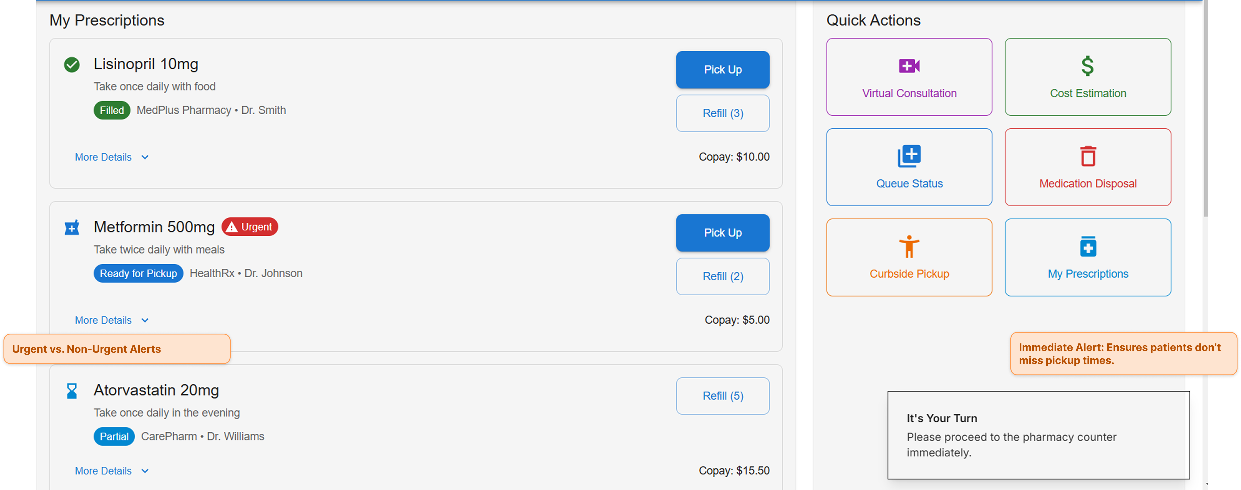

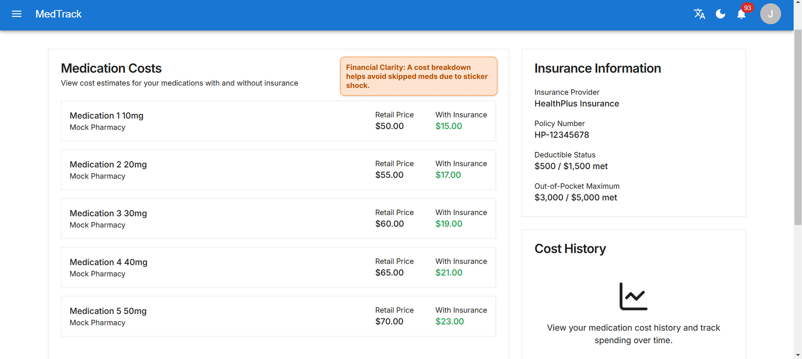

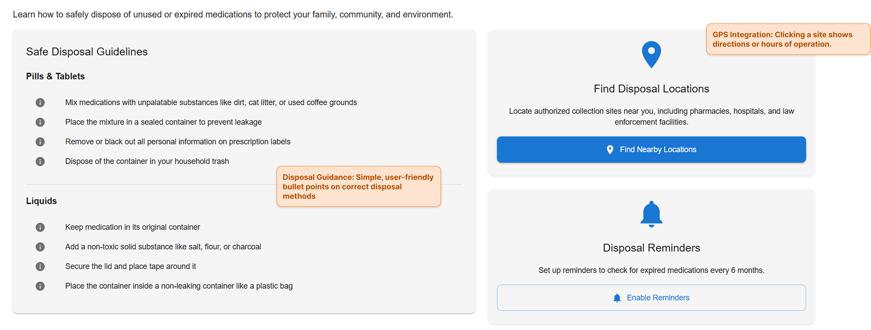

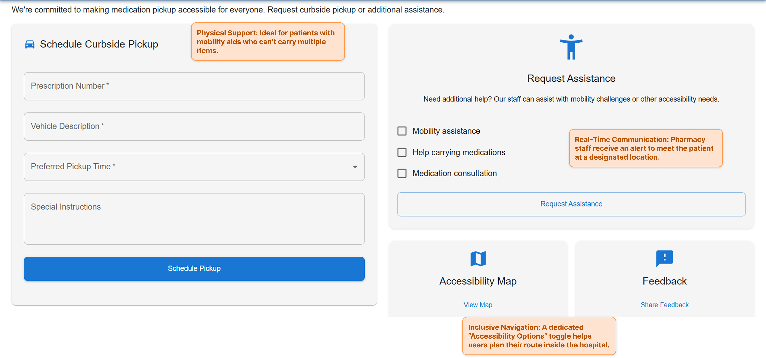

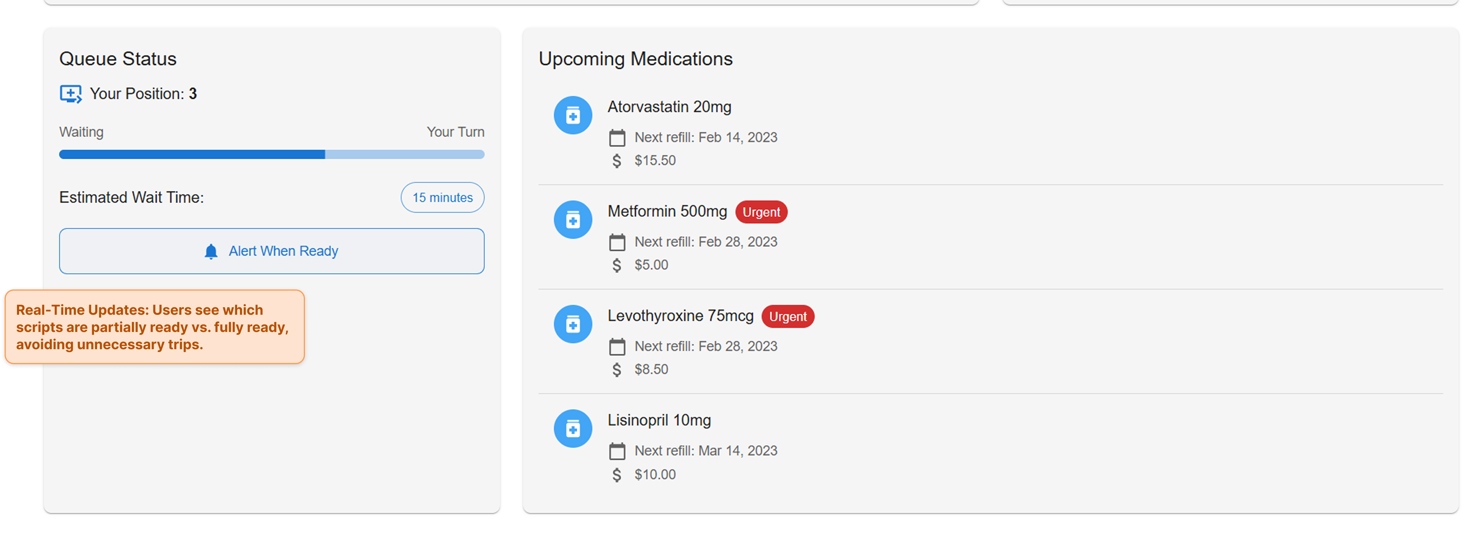

**References**

MyTherapy. (n.d.-a). *Press: MyTherapy pictures for journalists and bloggers.* Retrieved from <https://www.mytherapyapp.com/press>

MyTherapy. (n.d.-b). *Medication Reminder and Pill Tracker App ⏰– MyTherapy.* Retrieved from [https://www.mytherapyapp.com](https://www.mytherapyapp.com/)

MyTherapy. (n.d.-c). *MyTherapy: Medication Reminder [Mobile application software].* App Store. Retrieved from [https://apps.apple.com](https://apps.apple.com/)

MyTherapy. (n.d.-d). *MyTherapy and Accessibility: Medication Management for Everyone.* Retrieved from <https://www.mytherapyapp.com/blog/mytherapy-accessibility>

MyTherapy. (n.d.-e). *MyTherapy 3.0 Connects Family Members For Improving Medication Adherence - Irish Tech News.* Retrieved from <https://www.irishtechnews.ie/mytherapy-3-0-connects-family-members-for-improving-medication-adherence/>

Healthify. (n.d.). *MyTherapy Meds & Pill Reminder app.* Retrieved from <https://healthify.com/blog/mytherapy-app-review>

Medpsych. (n.d.). *The Importance of Regularly Reviewing and Updating your Medication List with your Doctor.* Retrieved from [https://medpsych.net](https://medpsych.net/)

Why Personalized Interventions for Non-Adherence are Critical. (n.d.). Retrieved from [https://www.example-resource-nonadherence.com](https://www.example-resource-nonadherence.com/)

**Appendix**

**Raw Notes from Observational Study at Beth Israel Deaconess Medical Center**  
*Time of the Day: 3:30 PM to 4:30 PM*

- Questions on Insurance coverage for the prescriptions  
- Patient may be on a wheelchair  
- Pharmacist calls out patient's name when the medicines are ready (but what if patients have hearing disabilities, what about accents or wrong name pronunciations, can it lead to miscommunications or delays?)  
- Patients have to wait in line when they first visit  
- sometimes patient may not be in the waiting area when their names are called out. They may go for tests/visit the cafeteria or simply go outside in the lobby area and wait there with other family members.  
- usually the wait times are probably around 20 mins (maybe more or less) and is given immediately if the prescriptions are readily available   
- patients (or their nurse/fam member) have a name and a case number that they share so pharmacists can retrieve details/prescriptions  
- patients may read books, spend time talking on the phone, spend time on social media, or use YouTube/OTT platforms while they wait   
- Pharmacists ask for Name, DoB, ID, address before giving out the medicines, patients also need to sign at the end after picking up the medication   
- environment is pretty well lit, there is that usual medicine smell, the waiting area is not noisy. There are mulitple posters to download their med management app. The area also mentions the rights that patients have. There is a tv but it's switched off. There's sanitizer as well. Entrance has a big enough title indicating that this area is a pharmacy. There is an evacuation plan stuck to the wall.   
- Questions on allergies   
- Patients receive a Bag with medicines which is sorta sealed with a rounded tape. There's no handle on the bag  
- Questions on if Pharmacists have the patient's case on file   
- Patients have to remember (what seems like) a case number - it's short so easy to recall but I've heard patients mention longer numbers, I wonder what that's for  
- patients usually have bags that they're already holding (could be a backpack, purse)  
- Seating capacity is 13-15 people. 7 chairs and a central sofa. They're pretty comfortable. They're all in Blue. The whole color scheme is blue/white/brown  
- There is a medication disposal bin but needles aren't allowed. There are clear instructions about its usage in English and Spanish. There are 7 bullet points and each point is 2-3 lines long.   
- patients may not only speak in English but also in maybe Spanish  
- There's a CCTV camera for security   
- People may wear masks or may not - it's not mandatory   
- Counters have a protective glass and are separated by other glasses. Patients can still hear conversations and interactions of other patients. So there's no privacy (incase the patient is hesitant about mentioning the medicine out loud for any reason)  
- it's about 4 in the afternoon and the range of patients waiting or in line at a time has been around 1-8. The waiting time in line was less than 5 minutes with 6 counters.  
- Patients don't really pay attention to the posters. maybe when they're waiting but I haven't seen anybody actively stand and read any poster   
- There are moments when nobody's at the counter but it's for really short negligible times.   
- Questions about waiting times, some medicine might be available later/on a later day. Some are good for only certain days so patients clarify that  
- There are indoor plants  
- Physical receipt. no mention of emailing receipts or even asking patients if they want an electronic one  
- Some may have multiple prescriptions and maybe some are ready but other's arent  
- There's a dedicated area for patient counseling  
- Have a prescription but first consider if the medication fits the budget. They may look for other options if not  
- Some received a vague instruction like - pick up the medication for their friend and they were a bit confused as to what to do, what information do they need etc but this doesn't seem to be a problem as the pharmacists do seem to have the relevant information or the process to retrieve the information

*Quick note: Although the assignment suggested spending a couple of hours, I only spent about an hour in the pharmacy area. I also checked the cafeteria, but it was mostly empty at the time.*